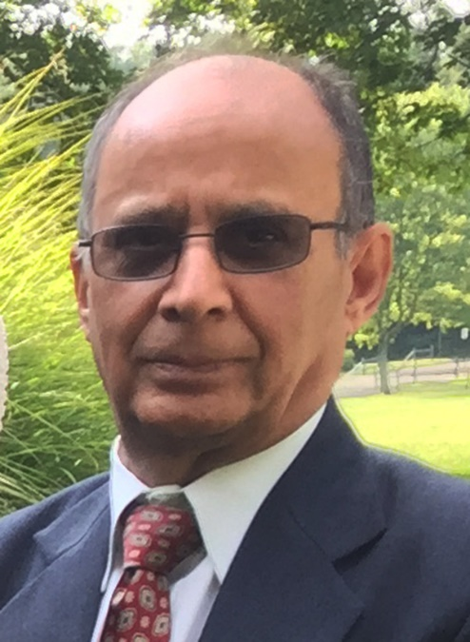

Humility and Tenacity
a tribute to
Inder Krishen Bhat

Maharaj Kaul

Inder Krishen Bhat, a stellar personality, passed away on the morning of September 23, 2017, in
Falls Church, Virginia, at the age of 71.

The last time I met Inderji was at the KOA East Coast Camp in July, 2017. He was as usual low-key, self-effacing, and yet a determined KOA worker. Though we never became friends, due to distance between New York and Virginia, but that did not matter, as I always felt his shine.

I had met Inderji at several KOA camps. He consistently possessed all the qualities indicated above. His strength came from a solid confidence in his values. He carried the same personality traits in his relationships with relatives and friends.

Inderji was born in Muran, a village in Kashmir, to Triloki Nath and Inderawati Bhat, in 1946. After his schooling in Jammu and Kashmir, he studied college in Agra. M.B.B.S he studied in Government Medical College, Srinagar, in 1968. .M.D. in Surgery in Maulana Azad Medical College, New Delhi.

In 1974 he arrived in U.S. He went through internship in St. Agnes Hospital in Baltimore, Maryland, in 1974-75. Residency in Surgery was done in Sinai Hospital, Baltimore, in 1975-1979 and residency in Colon and Rectal Surgery in Temple University Hospital, Philadelphia, Pennsylvania, in 1980. After the completion of his training he opened a private practice in 1981, in Virginia, where he had also been living.

He is survived by his spouse, Kamini, children: Vineet and Neeraj. The former is married to Misha and they have three children; the latter is married to Gretchen and they have two children.

Inderji was one of the bulwarks of KOA. Though officially he attained positions in its management only twice: once as a Newsletter Editor, and twice as a Secretary, but his influence in it was considerably greater. He was like the Socrates of the organization. Especially in Maryland and Virginia, where without his approval KOA Zone 4 significant activities virtually could not be done. On the 25th anniversary of KOA, he presented to it and the campers a CD carrying pictures from previous camps.

For many years a time slot at the Camps was reserved for Inderji: it was for his narration of light Urdu poetry. Often it was in humorous vein. He was sought in the Camps for his advice and work assignments.

Besides interests in poetry, Inderji also took interest in U.S. politics. He helped some candidates in elections. He was also known for his humorous remarks and actions.

A noble and cherished Kashmiri Pandit has passed away. His family, relatives, friends, and KP community in U.S. are the poorer for that. The rub is that he left them at the young age of 71. But people like Inderji never die, their light continues to shine over the people who knew them.

Suffern, New York, October 5, 2017.
www.kaulscorner.com
maharaj.kaul@yahoo.com

